1. Identify the personas/imagined users for the products

Foreign currency traders.

1. Identify other stakeholders of the projects (People other than direct users who you could require data or input from or who may indirectly benefit from the product).

Investment advisors might also benefit from our product as they make educated investments for their clients.

Map:

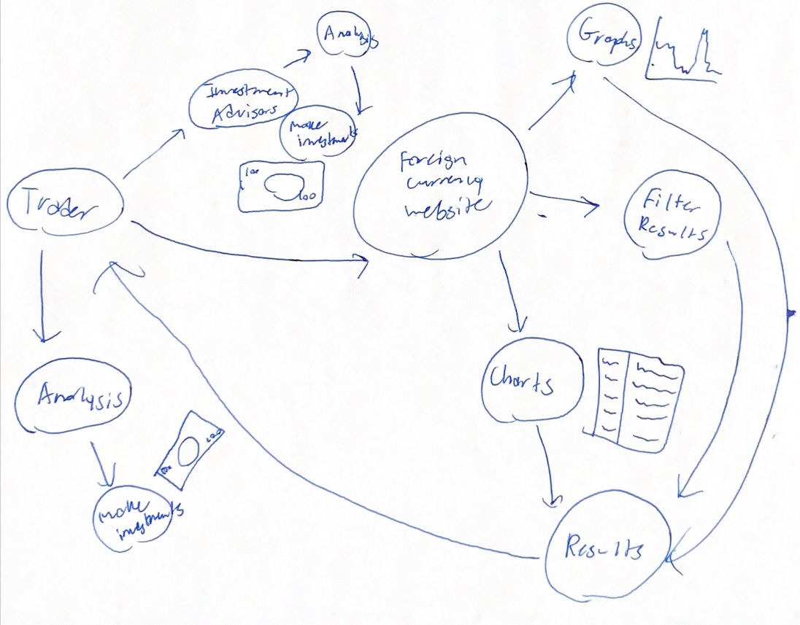

User Stories:

As a foreign currency trader, I would like to be able to search for specific currency trade exchange rates.

As a foreign currency trader, I would like to be able to organize currency trade information into charts or graphs.

As a foreign currency trader, I would like to filter results to find specific information.

Requirements List:

* A database of foreign currency information to search from
* A filter system to find specific information
* A charting and graphing system to organize information into visuals
* A website that can display all of this information and graphics
* Other visuals to bring allow for more information to be displayed